THE SUSTAINABLE DEVELOPMENT GOALS
&
WOMEN, PEACE AND SECURITY

ISSUE PAPER

Sharon Smee, Nicole Kleppe and Ludmilla Kwitko

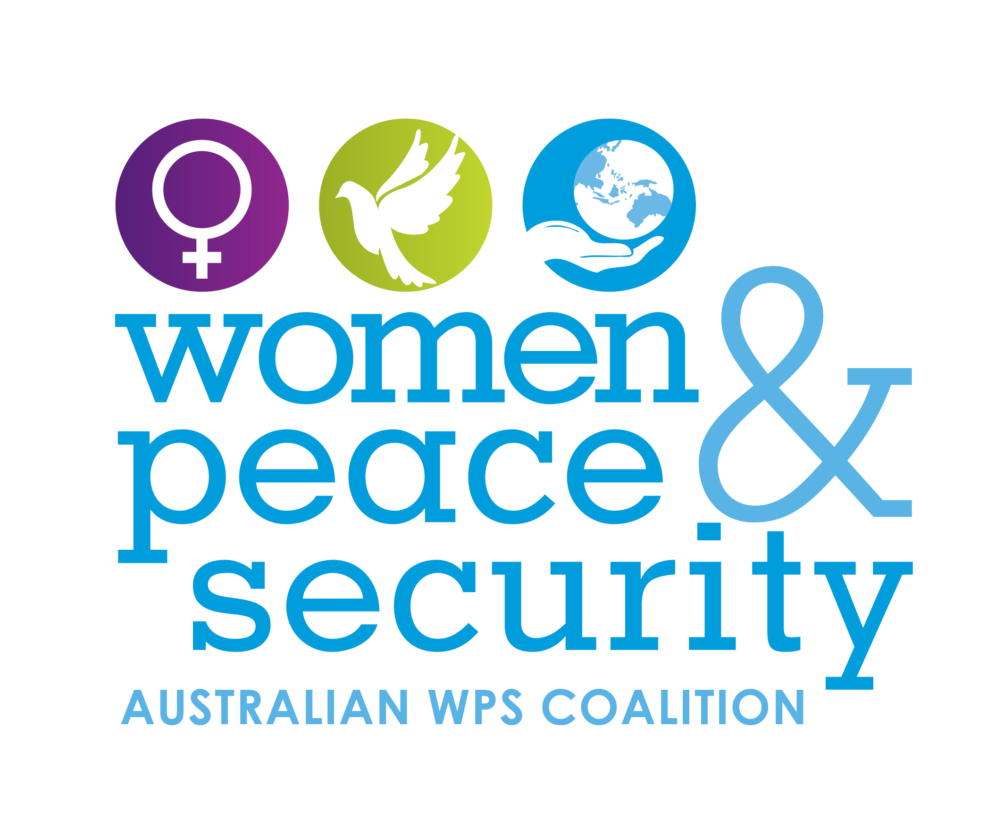

The Australian Civil Society Coalition for WPS
The Australian Civil Society Coalition on Women, Peace and Security is a non-partisan and independent coalition of civil society organisations, networks and individuals working to advance the Women, Peace and Security (WPS) Agenda in Australia, Asia and the Pacific region and globally.

Our vision is a world in which gender equality, and the contributions and rights of diverse women and girls, are at the forefront of transforming conflict to build peace.

www.wpscoalition.org

Issue Papers
The Australian Civil Society Coalition on Women Peace and Security commissioned the writing of thematically focused Issue Papers to inform the development of Australia's second National Plan on Women, Peace and Security (2nd NAP) and to advance the discussion on women, peace and security in Australia. These Issue Papers build on key themes outlined in “Listening to Women’s Voice and Making the Connections to the Women, Peace and Security Agenda: Fifth Report of the Annual Civil Society Dialogue on Women, Peace and Security.”

Issue Paper Contributors
The Australian WPS Coalition thanks Sharon Smee, Nicole Kleppe and Ludmilla Kwitko for their contribution.

Sharon Smee is Senior Manager – Program, Policy & Advocacy at the International Women’s Development Agency. Working as a policy advisor and consultant for over ten years both internationally and in Australia, Sharon has developed extensive experience in researching women's rights issues and analysing gender and development policy and practice. Sharon was previously a Senior Advisor with IWDA’s Research, Policy & Advocacy team and now leads IWDA’s policy and advocacy work with partners in the Pacific and Asia. She represented IWDA on the Steering Group of the Australian Civil Society Coalition on Women, Peace and Security from 2015 to May 2018. Sharon is a qualified lawyer and has a Master’s Degree in Peace and Conflict Studies.

Nicole Kleppe is undertaking a Master’s degree in International Relations at the University of Melbourne and is currently completing an internship with IWDA’s Research, Policy and Advocacy Team. From the United States, she has come to Australia to pursue her interests in the Women, Peace and Security sector and aims to work as gender advisor in the development sector.
Ludmilla Kwitko is a researcher and policy analyst with experience working on women, peace and security and international aid and development, in conflict, post-conflict settings, and emergency humanitarian and civil-military cooperation contexts. Dr Kwitko works with civil society organisations, governments, and multilateral organisations, in Australia and internationally. She is a member of the Australian Civil Society Coalition on Women, Peace and Security, and Women’s International League for Peace and Freedom. Dr Kwitko is Associate Professor (Honorary) at the College of Asia and the Pacific, Australian National University.
Linking the Women, Peace and Security Agenda with the Sustainable Development Goals

As Australia moves towards the next iteration of its National Action Plan on Women, Peace and Security (2nd NAP), it is critical to link the 2nd NAP with existing international commitments such as the Convention on the Elimination of Discrimination Against Women, and the 2030 Agenda for Sustainable Development. Critically, the 2030 Agenda which is universally applicable to all countries recognises that there can be “no sustainable development without peace and no peace without sustainable development.”

The 2030 Agenda is made up of 17 Sustainable Development Goals (SDGs) - all of which have global, national and local consequences. The two SDGs most relevant to the Women, Peace and Security (WPS) agenda are Goals 5 - achieve gender equality and empower all women and girls and Goal 16 - promote peaceful and inclusive societies for sustainable development, provide access to justice for all and build effective, accountable and inclusive institutions at all levels.
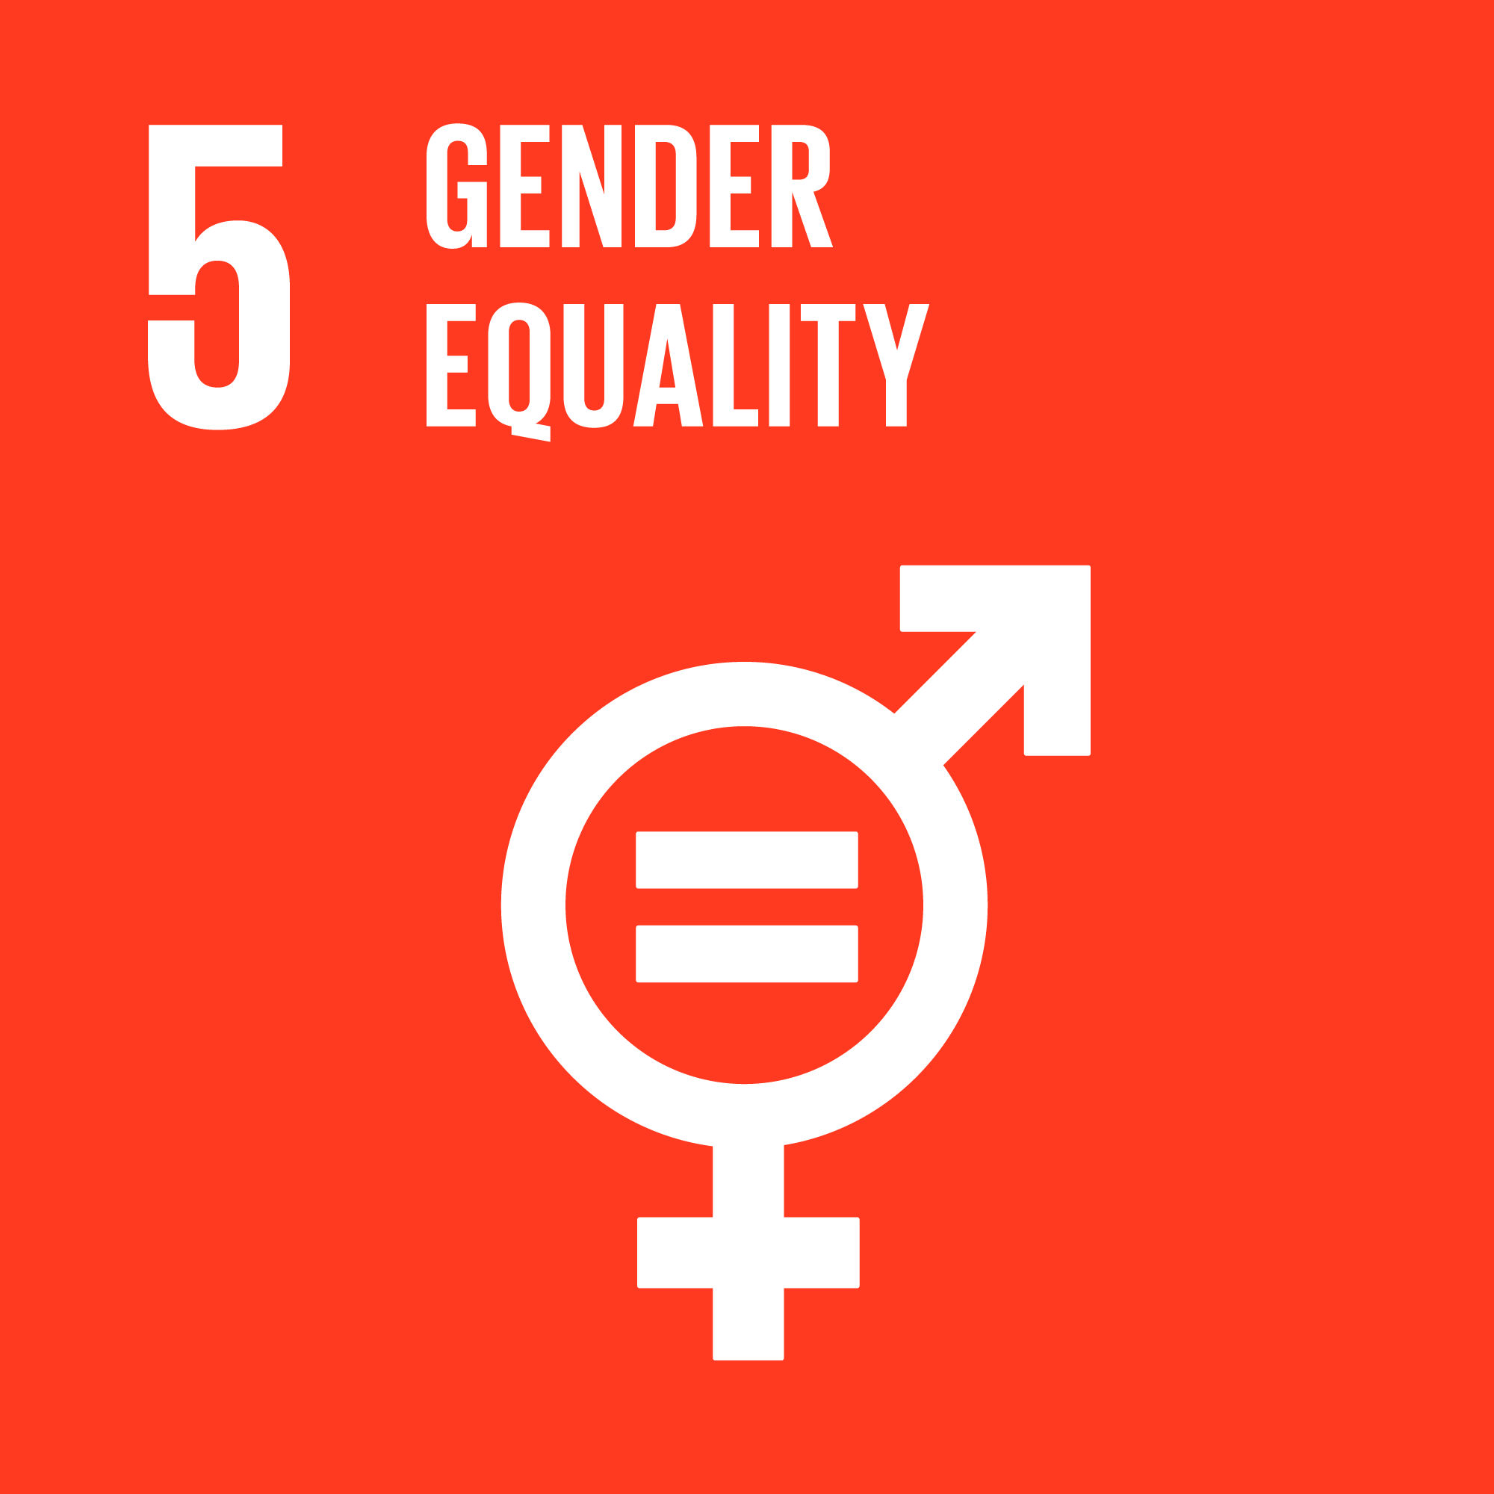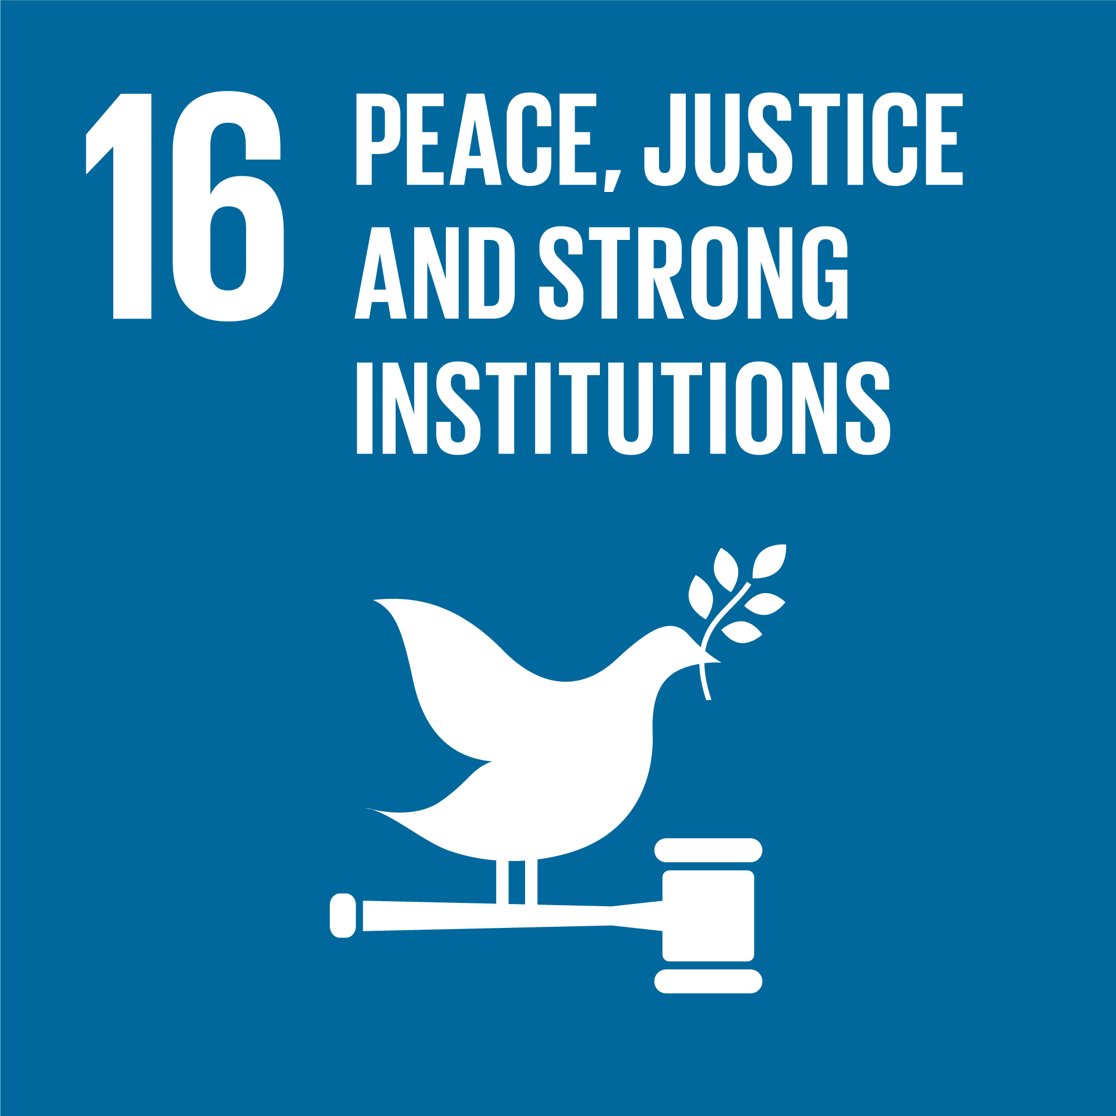

Importantly, the SDGs focus on a people-centred human security approach which recognises that we cannot achieve poverty eradication and sustainable development without tackling conflict and insecurity, to promote sustainable peace and development. Evidence shows that countries that have managed to reduce violence have also produced some of the fastest development gains.’
The Women, Peace and Security agenda is recognised as a prerequisite for the fulfilment of the 2030 Agenda and as essential for transformative change towards security, human rights and development. At the same time, the 2030 Agenda provides an important framework to refocus and strengthen Australia’s approach to women, peace and security clearly showing the “nexus between gender equality, conflict and development” and the need for an interlinked domestic and international focus on women, peace and security.

2nd NAP’s Vision
Australia’s 2nd NAP should align with the vision of the 2030 Agenda and SDGs, particularly Goal 5 (achieve gender equality) and Goal 16 (promote peaceful and inclusive societies). The 2nd NAP should expand on the focus of the 1st NAP prioritising a focus on prevention and the full and equal and meaningful participation of women in conflict prevention and the building and maintenance of peace and security. This approach should take into account community-led definitions of peace and security in Australia and our region, which acknowledge the importance of women’s leadership and participation and supporting and resourcing women’s rights organisations in women, peace and security policy and practice.
What Does This Mean for Australia’s Next NAP?
(a) Integrating the SDGs into the 2nd Australian NAP
As the Australian Government considers the goal and vision of the 2nd NAP, it is vital to expand the focus from protection to prevention and prioritise the full and effective participation of women. The focus can be expanded by including an explicit reference to the SDGs in the NAP and by Australia specifically integrating the links between Goal 5 and Goal 16 and the WPS Agenda. Some current NAPs acknowledge the importance of the SDGs to enhance women, peace and security policy and practice coherence. For example, the German NAP on WPS recognises that the SDGs are interdependent with WPS and pledges coherent policy to achieve both commitments. Canada’s 2nd NAP notes the importance of the SDGs Framework and specifically the alignment of SDG 5 and 16 with the WPS agenda. Sweden’s 3rd NAP also acknowledges the SDGs as a key starting point for unified international commitment to the WPS Agenda.
Acknowledging the alignment between these agendas affirms the connection between development and security and the need for a “human security” approach which equally prioritises the social and economic dimensions of all people’s lives. The global objectives for sustainable development in the 2030 Agenda, particularly Goals 5 and16, also provide a useful global framing for WPS priorities and practice.
(b) Connecting domestic and international issues and implementation
The SDGs also provide a framework for the 2nd NAP to interlink a domestic and international focus on WPS. The SDGs require that progress against Goal 16 and Goal 5 is reported both in domestic implementation as well as progress through Australia’s international engagement, such as the international aid and development program, defence policy, peacekeeping efforts, support to humanitarian emergencies and domestic peace and security policy and practice. During 2017, this linkage was recognised by community-based Roundtable discussions (organised by the WPS Coalition) which provided unequivocal community support for a peace and security agenda that has a strong domestic focus, while recognising the need to be linked with international priorities and activities as well. This “dual focus for peace and security” illustrates how coherent domestic and international policy can contribute to overall peace and security (Annex A).
(c) Linking with SDGs and other cross-government mechanisms and plans
Australia has an important opportunity to demonstrate cross-government coordination and leadership by integrating the SDGs into the 2nd Australian NAP on WPS. Explicit links are required between implementation mechanisms for the 2nd NAP and Australia’s current SDGs implementation mechanisms. For example, it would increase effectiveness in planning and implementation to see links between Australia’s 2nd NAP on WPS and the SDG Inter-Departmental Committee (co-chaired by Deputy Secretaries of Department of Foreign Affairs and Trade, Prime Minister and Cabinet) as well as the Australian Bureau of Statistics work to support the whole-of-government response to reporting on the SDGs. A “joined-up approach” which recognises the intersection between the WPS and the SDGs agendas can facilitate sharing of knowledge, best practice and resources.
Nations who have made strong commitments to the SDGs have already begun to integrate the SDGs within existing cross-government coordination mechanisms and action plans in recognition that they may improve implementation. For examples of this cross-government integration see the UK, Germany, Indonesia, and Nigeria. For other illustrations of best practice see the UNDP Guidance Notes on Institutional and Coordination Mechanisms. Australia’s 2nd NAP provides Australia with an excellent opportunity to showcase this commitment to SDGs and alignment across government mechanisms and policies.
Also, cooperation with other countries in the region through exchanging lessons learnt, good practice and research findings of the implementation of the WPS Agenda including NAPs and interlinkages with the 2030 Agenda should also be identified as a strategy in the 2nd NAP.
(d) Drawing on the SDGs to set priorities and inform monitoring, evaluation and learning for Australia’s 2nd NAP
SDGs make a critical contribution to informing the development of Australia’s 2nd NAP by shaping the monitoring, evaluation and learning framework. The SDGs can help the NAP answer the key questions about how it (and all the international and domestic strategies and activities) has contributed to changing and improving sustainable peace and how it has contributed to the WPS agenda.
Specifically, the 2nd NAP can utilise the SDG targets and indicators to inform priorities and the monitoring and evaluation framework. SDGs targets and indicators can track gender equality, women’s empowerment, women’s rights and peaceful, inclusive societies. For example, the UK NAP has integrated relevant SDG targets into WPS tracking so that data collection is improved and shared across ministries and departments.
Also, Annex B provides an example of mapping SDG targets (within Goals 5 and 16) against the four pillars of the WPS Agenda. For example, Target 5.5 - to ensure women’s full and effective participation and equal opportunities for leadership at all levels of decision-making in political, economic and political life is relevant to progress against the Women, Peace and Security participation pillar (to ensure women participate meaningfully in decision-making processes related to the prevention and resolution of conflict) as well as to the conflict prevention pillar (which necessitates women’s role in conflict prevention in fragile states is both recognised and supported).
(e) Promoting the role of civil society in the implementation of the SDGs and WPS Agenda
Engagement and collaboration with civil society, in particular, women organisations and networks, has been identified as integral to implementing both the SDGs and the WPS Agenda. The development of the 2nd NAP should prioritise engagement with conflict-affected women in the region. The 2nd NAP should explicitly recognise the involvement and agency of women leaders, women organisations and networks as key to sustainable development and an effective WPS agenda. It should also include strategies for enhancing the involvement and influence of civil society actors in promoting both WPS and SDG agendas.
Recommendations
- Australia’s 2nd NAP should align with the vision of the 2030 Agenda and SDGs, particularly Goal 5 (achieve gender equality) and Goal 16 (promote peaceful and inclusive societies).
- Make an explicit reference to the SDGs in the NAP including specific acknowledgment of the links between Goal 5 and Goal 16.
- The SDGs should be utilised as a framework to interlink a domestic and international focus on women, peace and security in the 2nd NAP.
- The 2nd NAP must demonstrate how Government policies, plans, and actions are promoting peace and security both domestically and internationally, in line with the SDGs Agenda.
- In line with the SDGs, the 2nd NAP must expand the focus from protection to prevention, prioritising the full and effective participation of women in the maintenance of peace and security and conflict prevention.
- Make explicit links between implementation mechanisms for the 2nd NAP and Australia’s current SDGs implementation mechanisms and data collection efforts.
- Cooperation with other countries in the region through exchanging lessons learnt good practice and research findings of the implementation of the Women, Peace and Security Agenda and interlinkages with the 2030 Agenda are identified as a strategy in the 2nd NAP.
- The 2nd NAP should utilise the SDG targets and indicators to inform priorities and the monitoring and evaluation framework.
- The development of the 2nd NAP should prioritise engagement with conflict-affected women in the region, and the NAP should explicitly recognise, and develop strategies to enable, the involvement and agency of women leaders, women organisations and networks as key to sustainable development and an effective WPS agenda.
Want to know more?
United Nations (2015), ‘Transforming Our World: the 2030 Agenda For Sustainable Development,’ available at https://sustainabledevelopment.un.org/post2015/transformingourworld/publication
The Australian Civil Society Coalition for Women, Peace and Security (2017), ‘Listening to Women’s Voices and Making the Connections to The Women, Peace and Security Agenda,’ Fifth Report of the Annual Civil Society Dialogue on Women, Peace and Security, available at http://wpscoalition.org/wp-content/uploads/2018/03/CivilSociety_2018_report_ART_web.pdf
International Women’s Development Agency (2016), ‘The Global Goals: Women, Peace and Security’, Policy Brief, available at https://www.iwda.org.au/assets/files/20160119-WPS-and-Goal-16-policy-brief_EK2.pdf
The Australian Civil Society Coalition on Women Peace and Security (2018), ‘The Australian Civil Society Coalition on Women Peace and Security: Submission to the Senate Inquiry into the United Nations Sustainable Development Goals (SDGs)’, available at https://www.aph.gov.au/Parliamentary_Business/Committees/Senate/Foreign_Affairs_Defence_and_Trade/SDGs/Submissions
UN Women, ‘Preventing Conflict Transforming Justice Securing the Peace’, A Global Study on the Implementation of United Nations Security Council Resolution 1325, p. 88, available at http://www.unwomen.org/~/media/files/un%20women/wps/highlights/unw-global-study-1325-2015.pdf
United Nations Security Council (2017), ‘Report of the Secretary-General on Women and Peace and Security,’ S/2017/861, available at https://reliefweb.int/sites/reliefweb.int/files/resources/N1733043.pdf
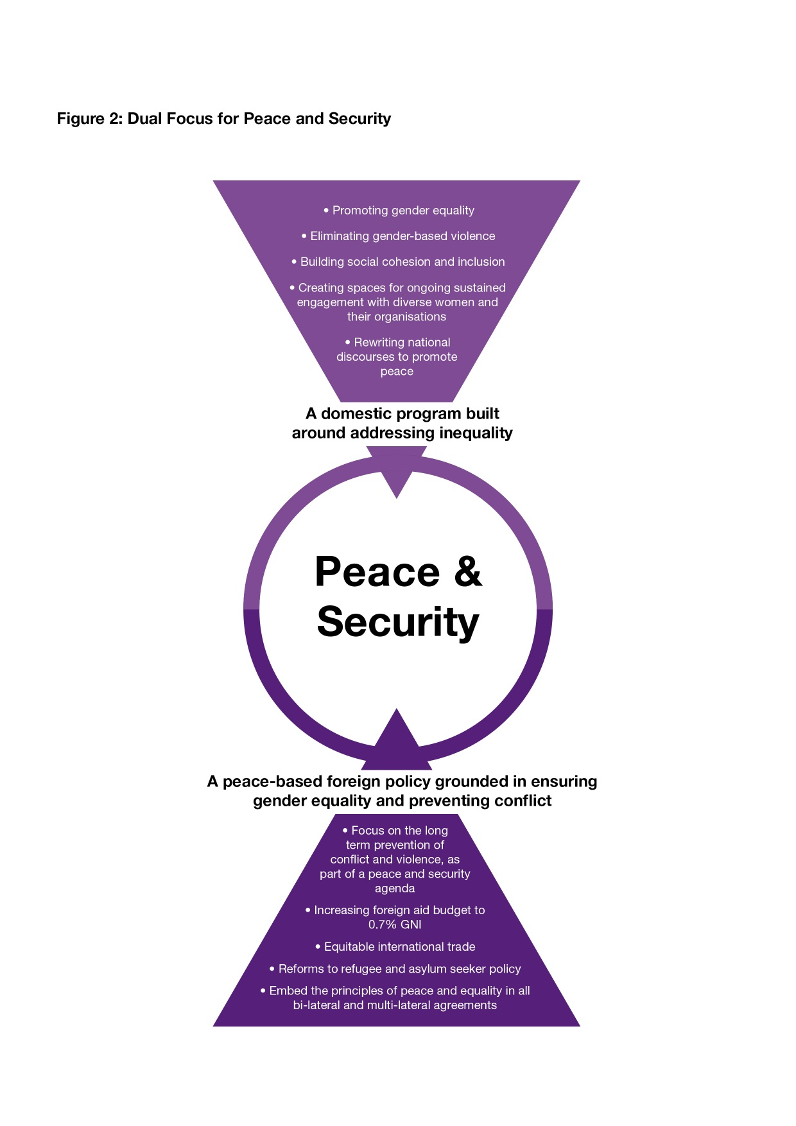
Annex A
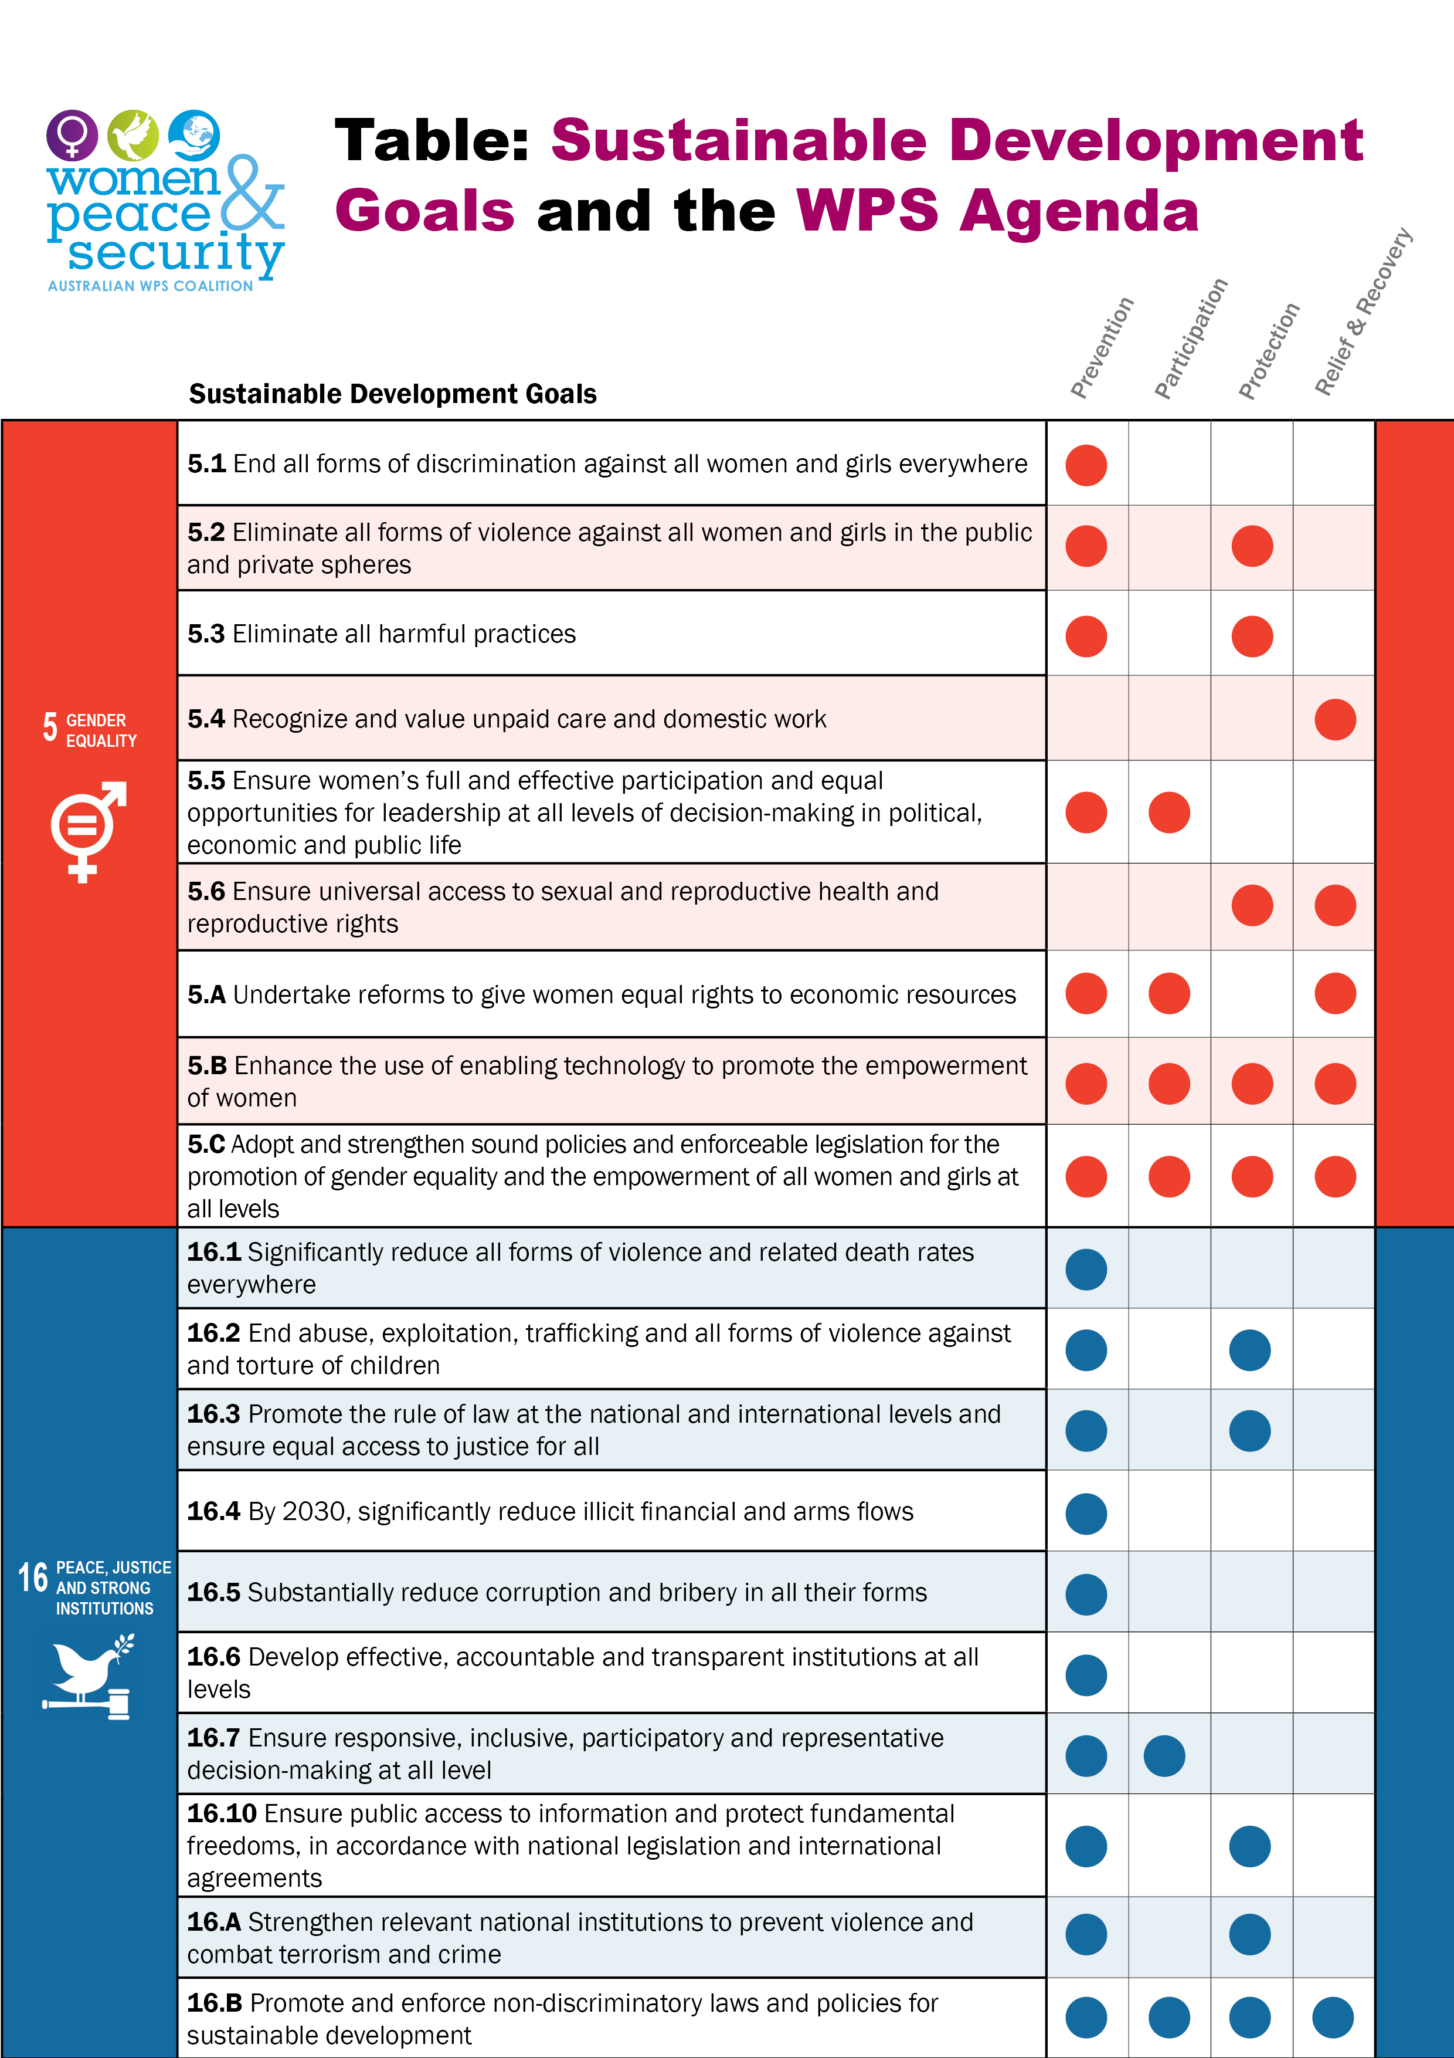
Annex B

Including Critical Area of Concern E on Women and Armed Conflict in the Beijing Platform for Action; the Convention on the Elimination of Discrimination against Women (CEDAW); CEDAW General Recommendation 30 on women in conflict prevention, conflict and post-conflict situations; and the Sustainable Development Goals.
Resolution adopted by the UN General Assembly on 25 September 2015. Transforming our world: the 2030 Agenda for Sustainable Development (page 2/35). Sustainable Development Knowledge Platform https://sustainable development.un.org
World Bank (2011), ‘World Development Report 2011’, Conflict Security and Development, p. 50, available at: https://siteresources.worldbank.org/INTWDRS/Resources/WDR2011_Full_Text.pdf
United Nations Security Council (2017), ‘Report of the Secretary- General on Women and Peace and Security,’ S/2017/861, available at: https://reliefweb.int/sites/reliefweb.int/files/resources/N1733043.pdf
UN Women, ‘Preventing Conflict Transforming Justice Securing the Peace’, A Global Study on the Implementation of United Nations Security Council Resolution 1325, p. 31, available at: http://www.unwomen.org/~/media/files/un%20women/wps/highlights/unw-global-study-1325-2015.pdf
The Australian Civil Society Coalition for Women, Peace and Security (2017), ‘Listening to Women’s Voices and Making the Connections to The Women, Peace and Security Agenda,’ Fifth Report of the Annual Civil Society Dialogue on Women, Peace and Security, available at: http://wpscoalition.org/wp-content/uploads/2018/03/CivilSociety_2018_report_ART_web.pdf
Note the 3rd National Action Plans of Sweden and Netherlands reference the 2030 Agenda.
Government of the Federal Republic of Germany (2017), ‘Action Plan of the Federal Republic of Germany on the Implementation of United Nations Security Council Resolution 1325 on Women Peace and Security for the Period 2017-2020’ p. 15, available at: http://www.peacewomen.org/nap-germany
Government of Canada (2017), ‘Canada’s National Action Plan 2017-2022 For the Implementation of the UN Security Council Resolutions on Women, Peace and Security’, p. 7, available at: http://international.gc.ca/world-monde/issues_development-enjeux_developpement/gender_equality-egalite_sexes/national_action_plan_wps-plan_national_action_fps.aspx?lang=eng
Government Offices of Sweden (2016), ‘Sweden’s National Action Plan for the Implementation of the UN Security Council Resolutions on Women, Peace and Security 2016-2020’, Women, Peace & Security, p. 16, available at: http://www.peacewomen.org/sites/default/files/Sweden%20NAP%202016-2020.pdf
See The Australian Civil Society Coalition for Women, Peace and Security (2017), ‘Listening to Women’s Voices and Making the Connections to The Women, Peace and Security Agenda,’ Op cit.
Ibid.
United Nations Development Programme (2017), ‘Institutional and Coordination Mechanisms Guidance Note on Facilitating Integration and Coherence for SDG Implementation,’ p. 37-41 available at: https://sustainabledevelopment.un.org/content/documents/2478Institutional_Coordination_Mechanisms_GuidanceNote.pdf
UN Women, ‘Preventing Conflict Transforming Justice Securing the Peace’, A Global Study on the Implementation of United Nations Security Council Resolution 1325, p. 319, available at: http://www.unwomen.org/~/media/files/un%20women/wps/highlights/unw-global-study-1325-2015.pdf
HM Government (2018), ‘UK National Action Plan on Women, Peace & Security 2018-2022’, p. 16, available at: https://assets.publishing.service.gov.uk/government/uploads/system/uploads/attachment_data/file/677586/FCO1215-NAP-Women-Peace-Security-ONLINE_V2.pdf
See for example, Report of the Secretary General (2015), Women’s Empowerment and the links to sustainable development, E/CN.6/2016/3, 31 December 2015, para: 23, available at: http://www.un.org/ga/search/view_doc.asp?symbol=E/CN.6/2016/3
See The Australian Civil Society Coalition for Women, Peace and Security (2017), ‘Listening to Women’s Voices and Making the Connections to The Women, Peace and Security Agenda,’ Op cit.

